**Karan Arora**  **R.L. Institute M: 9416974837**

**Max Time : 1 hr** **MOLE CONCEPT & SOLUTION Max Marks : 120**

**LEVEL – 1 CODE : A**

1. The average molar mass of chlorine is 35.5 g/mol. The ratio of 35Cl to 37Cl in naturally occurring chlorine is close to

|  |  |  |  |
| --- | --- | --- | --- |
| a) 4 : 1 | b) 3 : 1 | c) 2 : 1 | d) 1 : 1 |

1. 8 g of NaOH is dissolved in 18 g of H2O. Mole fraction of NaOH in solution and molality (in mol/kg) of the solution respectively are :

|  |  |  |  |
| --- | --- | --- | --- |
| a) 0.2 , 22.20 | b) 0.2 , 11.11 | c) 0.167 , 11.11 | d) 0.167 , 22.20 |

1. An unknown chlorohydrocarbon has 3.55 % of chlorine. If each molecule of the hydrocarbon has one chlorine atom only, chlorine atoms present in 1 g of chlorohydrocarbon are

|  |  |  |  |
| --- | --- | --- | --- |
| a) 6.023 x 109 | b) 6.023 x 1023 | c) 6.023 x 1021 | d) 6.023 x 1020 |

1. Choose the incorrect formula out of the four compounds for an element X below :

|  |  |  |  |
| --- | --- | --- | --- |
| a) X2O3 | b) X2Cl3 | c) X2(SO4)3 | d) XPO4 |

1. 10 mL of 2 M NaOH solution is added to 200 mL of 0.5 M of NaOH solution. What is the final concentration ?

|  |  |  |  |
| --- | --- | --- | --- |
| a) 0.57 M | b) 5.7 M | c) 11.4 M | d) 1.14 M |

1. The total number of electrons in one molecule of carbon dioxide is

|  |  |  |  |
| --- | --- | --- | --- |
| a) 22 | b) 44 | c) 66 | d) 88 |

1. 27 g of aluminium will react completely with how many grams of oxygen ?

|  |  |  |  |
| --- | --- | --- | --- |
| a) 8 g | b) 16 g | c) 32 g | d) 24 g |

1. A compound was found to contain nitrogen and oxygen in the ratio 28 g and 80 g respectively. The formula of compound is

|  |  |  |  |
| --- | --- | --- | --- |
| a) NO | b) N2O3 | c) N2O5 | d) N2O4 |

1. For a reaction, N2 (g) + 3 H2 (g) → 2 NH3 (g) ; identify dihydrogen (H2) as a limiting reagent in the following reaction mixtures.

|  |  |  |  |
| --- | --- | --- | --- |
| a) 56 g of N2 + 10 g of H2 | b) 35 g of N2 + 8 g of H2 | c) 28 g of N2 + 6 g of H2 | d) 14 g of N2 + 4 g of H2 |

1. 1 g of a carbonate (M2CO3) on treating with excess HCl produces 0.01186 mole of CO2. The molar mass of M2CO3 in g/mol is :

|  |  |  |  |
| --- | --- | --- | --- |
| a) 1186 | b) 84.3 | c) 118.6 | d) 11.86 |

1. The most abundant elements by mass in the body of a healthy human adult are :

Oxygen (61.4 %) ; carbon (22.9 %) ; hydrogen (10 %) and nitrogen (2.6 %). The weight which a 75 kg person would gain if all 1H atoms are replaced by 2H atoms is

|  |  |  |  |
| --- | --- | --- | --- |
| a) 15 kg | b) 37.5 kg | c) 7.5 kg | d) 10 kg |

1. The normality of 0.3 M phosphorous acid (H3PO3) is

|  |  |  |  |
| --- | --- | --- | --- |
| a) 0.1 | b) 0.9 | c) 0.3 | d) 0.6 |

1. The equivalent weight of MnSO4 is half of its molecular weight when it is converted to :

|  |  |  |  |
| --- | --- | --- | --- |
| a) Mn2O3 | b) MnO2 | c) | d) |

1. In which mode of expression, the concentration of a solution remains independent of temperature?

|  |  |  |  |
| --- | --- | --- | --- |
| a) Molarity | b) Normality | c) Formality | d) Molality |

1. *M* is molecular weight of KMnO4. The equivalent weight of KMnO4 when it is converted into K2MnO4 is

|  |  |  |  |
| --- | --- | --- | --- |
| a) M | b) M/3 | c) M/5 | d) M/7 |

1. An open beaker of water in equilibrium with water vapour is in a sealed container. When a few grams of glucose are added to the beaker of water, the rate at which water molecules :

|  |  |
| --- | --- |
| a) Leaves the vapour increases | b) Leaves the solution increases |
| c) Leaves the solution decreases | d) Leaves the vapour decreases |

1. A graph of vapour pressure and temperature for three different liquids X , Y and Z is shown below :

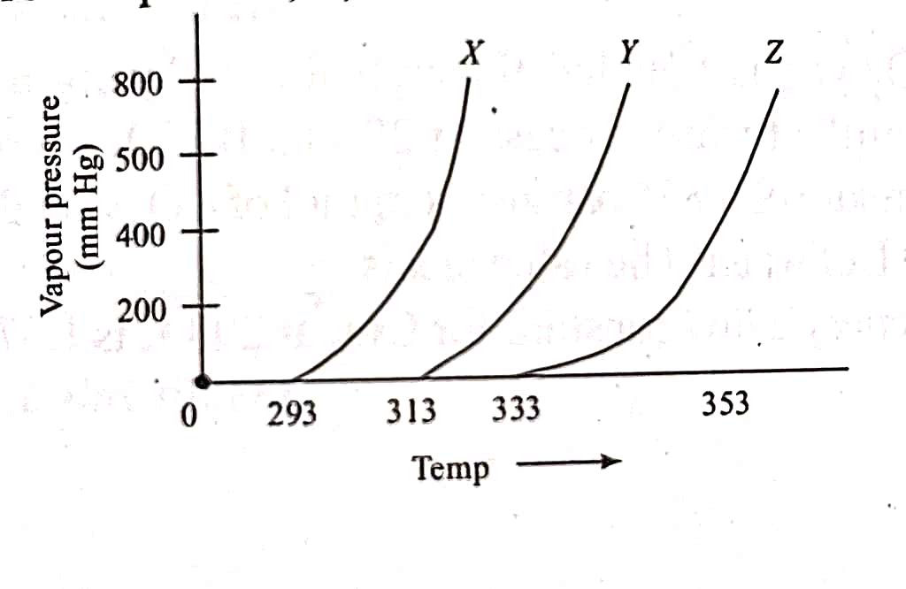

The following inferences are made :

(A) X has higher intermolecular interactions compared to Y.

(B) X has lower intermolecular interactions compared to Y.

(C) Z has lower intermolecular interactions compared to Y.

|  |  |  |  |
| --- | --- | --- | --- |
| a) (A) & (C) | b) (A) | c) (B) | d) (C) |

1. The mole fraction of a solvent in aqueous solution of a solute is 0.8. The molality (in mol/kg) of the aqueous solution is

|  |  |  |  |
| --- | --- | --- | --- |
| a) 13.88 x 10 – 2 | b) 13.88 x 10 – 1 | c) 13.88 | d) 13.88 x 10 – 3 |

1. What would be the molality of 20 % (mass/mass) aqueous solution of KI? (Molar mass of KI is 166 g/mol)

|  |  |  |  |
| --- | --- | --- | --- |
| a) 1.08 | b) 1.35 | c) 1.48 | d) 1.51 |

1. The solubility of N2 in water at 300 K and 500 torr partial pressure is 0.01 g/L. The solubility (in g/L) at 750 torr partial pressure is :

|  |  |  |  |
| --- | --- | --- | --- |
| a) 0.0075 | b) 0.005 | c) 0.02 | d) 0.015 |

1. Dissolving 120 g of urea in 1000 g of water gave a solution of density 1.15 g/mL. The molarity of the solution is :

|  |  |  |  |
| --- | --- | --- | --- |
| a) 1.78 M | b) 2 M | c) 2.05 M | d) 2.22 M |

1. At room temperature, a dilute solution of urea is prepared by dissolving 0.6 g of urea in 360 g of water. If the vapour pressure of pure water at this temperature is 35 mm Hg. Lowering of vapour pressure will be :

|  |  |  |  |
| --- | --- | --- | --- |
| a) 0.027 mm Hg | b) 0.028 mm Hg | c) 0.017 mm Hg | d) 0.031 mm Hg |

1. Elevation in the boiling point for 1 molal solution of glucose is 2 K. The depression in the freezing point for 2 molal solution of glucose in the same solvent is 2 K. The relation between Kb and Kf is :

|  |  |  |  |
| --- | --- | --- | --- |
| a) Kb = 1.5 Kf | b) Kb = Kf | c) Kb = 0.5 Kf | d) Kb = 2 Kf |

1. The freezing point (in ˚C) of a solution containing 0.1 g of K3[Fe(CN)6] (mol. Wt. 329) in 100 g of water. (Kf for water is 1.86 K/m.)

|  |  |  |  |
| --- | --- | --- | --- |
| a) - 2.3 x 10 – 2 | b) - 5.7 x 10 – 2 | c) - 5.7 x 10 – 3 | d) - 1.2 x 10 – 2 |

1. During depression of freezing point in a solution, the following are in equilibrium

|  |  |
| --- | --- |
| a) Liquid solvent , solid solvent | b) Liquid solvent , solid solute |
| c) Liquid solute , solid solute | d) Liquid solute , solid solvent |

**Numeric / New Stem Based Questions**

1. The number of atoms in 8 g of sodium is ‘*x’* X 1023. The value of x is ………………………… . (Nearest integer).
2. Sodium oxide reacts with water to produce NaOH. 20 g of sodium oxide is dissolved in 500 mL of water. Neglecting the change in volume, the concentration of the resulting NaOH solution is ……………….… x 10 – 1 M.
3. If the concentration of glucose in blood is 0.72 g/L, the molarity of glucose in blood is …………………. x 10 – 3 M.
4. If 80 g of copper sulphate CuSO4. 5H2O is dissolved in deionized water to make 5 L of solution. The concentration of the copper sulphate solution is ‘*x’* X 10 – 3 mol/L. The value of x is …………………………. .
5. CO2 gas is bubbled through water during a soft drink manufacturing process at 298 K. If CO2 exerts a partial pressure of 0.835 bar then ‘*x’* m mol of CO2 would dissolved in 0.9 L of water. The value of x is …………………. . (Henry’s Law constant for CO2 at 298 K is 1.67 x 103 bar).

**Karan Arora**  **R.L. Institute M: 9416974837**

**Max Time : 1 hr** **MOLE CONCEPT & SOLUTION Max Marks : 120**

**LEVEL – 1 CODE : B**

1. Dissolving 120 g of urea in 1000 g of water gave a solution of density 1.15 g/mL. The molarity of the solution is :

|  |  |  |  |
| --- | --- | --- | --- |
| a) 1.78 M | b) 2 M | c) 2.05 M | d) 2.22 M |

1. At room temperature, a dilute solution of urea is prepared by dissolving 0.6 g of urea in 360 g of water. If the vapour pressure of pure water at this temperature is 35 mm Hg. Lowering of vapour pressure will be :

|  |  |  |  |
| --- | --- | --- | --- |
| a) 0.027 mm Hg | b) 0.028 mm Hg | c) 0.017 mm Hg | d) 0.031 mm Hg |

1. During depression of freezing point in a solution, the following are in equilibrium

|  |  |
| --- | --- |
| a) Liquid solvent , solid solvent | b) Liquid solvent , solid solute |
| c) Liquid solute , solid solute | d) Liquid solute , solid solvent |

1. 27 g of aluminium will react completely with how many grams of oxygen ?

|  |  |  |  |
| --- | --- | --- | --- |
| a) 8 g | b) 16 g | c) 32 g | d) 24 g |

1. An unknown chlorohydrocarbon has 3.55 % of chlorine. If each molecule of the hydrocarbon has one chlorine atom only, chlorine atoms present in 1 g of chlorohydrocarbon are

|  |  |  |  |
| --- | --- | --- | --- |
| a) 6.023 x 109 | b) 6.023 x 1023 | c) 6.023 x 1021 | d) 6.023 x 1020 |

1. A compound was found to contain nitrogen and oxygen in the ratio 28 g and 80 g respectively. The formula of compound is

|  |  |  |  |
| --- | --- | --- | --- |
| a) NO | b) N2O3 | c) N2O5 | d) N2O4 |

1. For a reaction, N2 (g) + 3 H2 (g) → 2 NH3 (g) ; identify dihydrogen (H2) as a limiting reagent in the following reaction mixtures.

|  |  |  |  |
| --- | --- | --- | --- |
| a) 56 g of N2 + 10 g of H2 | b) 35 g of N2 + 8 g of H2 | c) 28 g of N2 + 6 g of H2 | d) 14 g of N2 + 4 g of H2 |

1. 1 g of a carbonate (M2CO3) on treating with excess HCl produces 0.01186 mole of CO2. The molar mass of M2CO3 in g/mol is :

|  |  |  |  |
| --- | --- | --- | --- |
| a) 1186 | b) 84.3 | c) 118.6 | d) 11.86 |

1. What would be the molality of 20 % (mass/mass) aqueous solution of KI? (Molar mass of KI is 166 g/mol)

|  |  |  |  |
| --- | --- | --- | --- |
| a) 1.08 | b) 1.35 | c) 1.48 | d) 1.51 |

1. The most abundant elements by mass in the body of a healthy human adult are :

Oxygen (61.4 %) ; carbon (22.9 %) ; hydrogen (10 %) and nitrogen (2.6 %). The weight which a 75 kg person would gain if all 1H atoms are replaced by 2H atoms is

|  |  |  |  |
| --- | --- | --- | --- |
| a) 15 kg | b) 37.5 kg | c) 7.5 kg | d) 10 kg |

1. The normality of 0.3 M phosphorous acid (H3PO3) is

|  |  |  |  |
| --- | --- | --- | --- |
| a) 0.1 | b) 0.9 | c) 0.3 | d) 0.6 |

1. The average molar mass of chlorine is 35.5 g/mol. The ratio of 35Cl to 37Cl in naturally occurring chlorine is close to

|  |  |  |  |
| --- | --- | --- | --- |
| a) 4 : 1 | b) 3 : 1 | c) 2 : 1 | d) 1 : 1 |

1. 8 g of NaOH is dissolved in 18 g of H2O. Mole fraction of NaOH in solution and molality (in mol/kg) of the solution respectively are :

|  |  |  |  |
| --- | --- | --- | --- |
| a) 0.2 , 22.20 | b) 0.2 , 11.11 | c) 0.167 , 11.11 | d) 0.167 , 22.20 |

1. The total number of electrons in one molecule of carbon dioxide is

|  |  |  |  |
| --- | --- | --- | --- |
| a) 22 | b) 44 | c) 66 | d) 88 |

1. The equivalent weight of MnSO4 is half of its molecular weight when it is converted to :

|  |  |  |  |
| --- | --- | --- | --- |
| a) Mn2O3 | b) MnO2 | c) | d) |

1. In which mode of expression, the concentration of a solution remains independent of temperature?

|  |  |  |  |
| --- | --- | --- | --- |
| a) Molarity | b) Normality | c) Formality | d) Molality |

1. Elevation in the boiling point for 1 molal solution of glucose is 2 K. The depression in the freezing point for 2 molal solution of glucose in the same solvent is 2 K. The relation between Kb and Kf is :

|  |  |  |  |
| --- | --- | --- | --- |
| a) Kb = 1.5 Kf | b) Kb = Kf | c) Kb = 0.5 Kf | d) Kb = 2 Kf |

1. The freezing point (in ˚C) of a solution containing 0.1 g of K3[Fe(CN)6] (mol. Wt. 329) in 100 g of water. (Kf for water is 1.86 K/m.)

|  |  |  |  |
| --- | --- | --- | --- |
| a) - 2.3 x 10 – 2 | b) - 5.7 x 10 – 2 | c) - 5.7 x 10 – 3 | d) - 1.2 x 10 – 2 |

1. *M* is molecular weight of KMnO4. The equivalent weight of KMnO4 when it is converted into K2MnO4 is

|  |  |  |  |
| --- | --- | --- | --- |
| a) M | b) M/3 | c) M/5 | d) M/7 |

1. An open beaker of water in equilibrium with water vapour is in a sealed container. When a few grams of glucose are added to the beaker of water, the rate at which water molecules :

|  |  |
| --- | --- |
| a) Leaves the vapour increases | b) Leaves the solution increases |
| c) Leaves the solution decreases | d) Leaves the vapour decreases |

1. A graph of vapour pressure and temperature for three different liquids X , Y and Z is shown below :



The following inferences are made :

(A) X has higher intermolecular interactions compared to Y.

(B) X has lower intermolecular interactions compared to Y.

(C) Z has lower intermolecular interactions compared to Y.

|  |  |  |  |
| --- | --- | --- | --- |
| a) (A) & (C) | b) (A) | c) (B) | d) (C) |

1. Choose the incorrect formula out of the four compounds for an element X below :

|  |  |  |  |
| --- | --- | --- | --- |
| a) X2O3 | b) X2Cl3 | c) X2(SO4)3 | d) XPO4 |

1. 10 mL of 2 M NaOH solution is added to 200 mL of 0.5 M of NaOH solution. What is the final concentration ?

|  |  |  |  |
| --- | --- | --- | --- |
| a) 0.57 M | b) 5.7 M | c) 11.4 M | d) 1.14 M |

1. The mole fraction of a solvent in aqueous solution of a solute is 0.8. The molality (in mol/kg) of the aqueous solution is

|  |  |  |  |
| --- | --- | --- | --- |
| a) 13.88 x 10 – 2 | b) 13.88 x 10 – 1 | c) 13.88 | d) 13.88 x 10 – 3 |

1. The solubility of N2 in water at 300 K and 500 torr partial pressure is 0.01 g/L. The solubility (in g/L) at 750 torr partial pressure is :

|  |  |  |  |
| --- | --- | --- | --- |
| a) 0.0075 | b) 0.005 | c) 0.02 | d) 0.015 |

**Numeric / New Stem Based Questions**

1. CO2 gas is bubbled through water during a soft drink manufacturing process at 298 K. If CO2 exerts a partial pressure of 0.835 bar then ‘*x’* m mol of CO2 would dissolved in 0.9 L of water. The value of x is …………………. . (Henry’s Law constant for CO2 at 298 K is 1.67 x 103 bar).
2. The number of atoms in 8 g of sodium is ‘*x’* X 1023. The value of x is ………………………… . (Nearest integer).
3. Sodium oxide reacts with water to produce NaOH. 20 g of sodium oxide is dissolved in 500 mL of water. Neglecting the change in volume, the concentration of the resulting NaOH solution is ……………….… x 10 – 1 M.
4. If the concentration of glucose in blood is 0.72 g/L, the molarity of glucose in blood is …………………. x 10 – 3 M.
5. If 80 g of copper sulphate CuSO4. 5H2O is dissolved in deionized water to make 5 L of solution. The concentration of the copper sulphate solution is ‘*x’* X 10 – 3 mol/L. The value of x is …………………………. .

**Answers**

**SOLUTION + MOLE CONCEPT [LEVEL – 1 ]**

|  |  |
| --- | --- |
| **CODE : A** | **CODE : B** |
| 1. b | 1. c |
| 2. c | 2. c |
| 3. d | 3. a |
| 4. b | 4. d |
| 5. a | 5. d |
| 6. a | 6. c |
| 7. d | 7. a |
| 8. c | 8. b |
| 9. a | 9. d |
| 10. b | 10. c |
| 11. c | 11. d |
| 12. d | 12. b |
| 13. b | 13. c |
| 14. d | 14. a |
| 15. a | 15. b |
| 16. a | 16. d |
| 17. c | 17. d |
| 18. d | 18. a |
| 19. d | 19. a |
| 20. d | 20. a |
| 21. c | 21. c |
| 22. c | 22. b |
| 23. d | 23. a |
| 24. a | 24. d |
| 25. a  26. 2  27. 13  28. 4  29. 64  30. 25 | 25. d  26. 25  27. 2  28. 13  29. 4  30. 64 |